**Name: Ammar Khan Reg No: FA24-BSE-148**

**Course: Object Oriented Programing Class: 3C**

**LAB 03**

**Student Marks Calculator:  
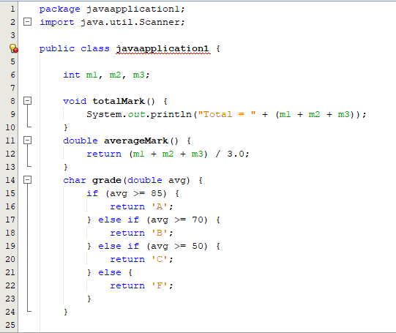**

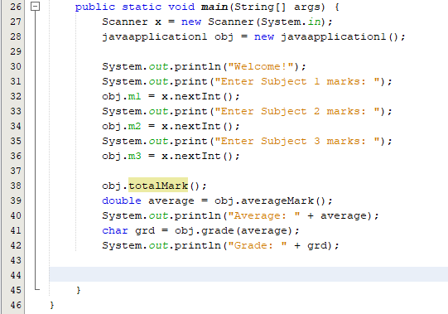

**Output:**

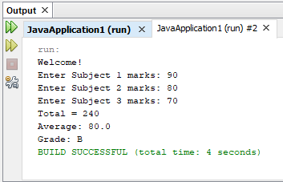

**Split bill Calculator:**

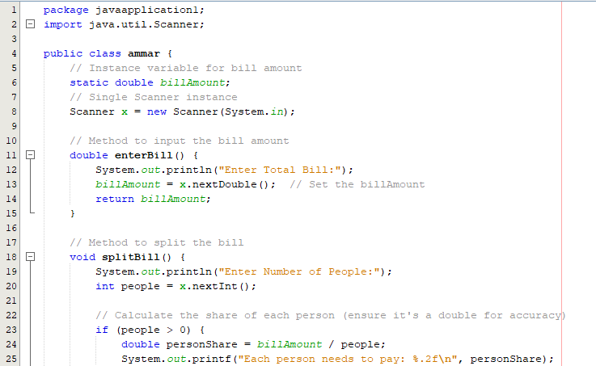

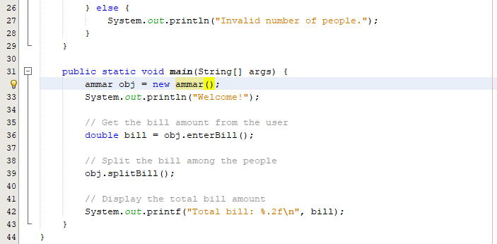

**Output:**

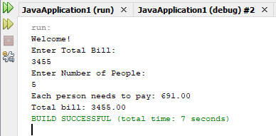

**Password Strength Checker:**